Excel Assignment - 12

Dataset:

https://docs.google.com/spreadsheets/d/1IRSEnmgz8Ro276-GslknRNk0zlrB5CZH1YrnT71kqFM/edit?usp=sharing

Use the above dataset and answer the following questions.

**1. What is the total amount of stationary bought from Madhya Pradesh?**

Ans: Rs. 176971/-

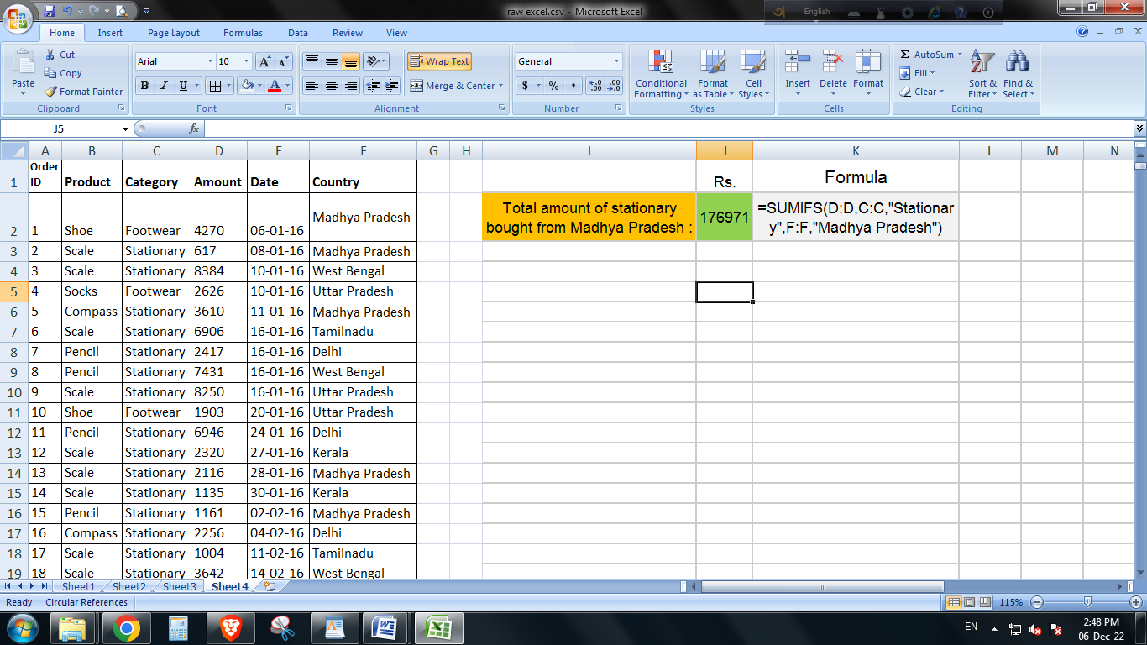

**2. What is the total count of stationary bought from Tamilnadu?**

Ans: 13 (Thirteen).

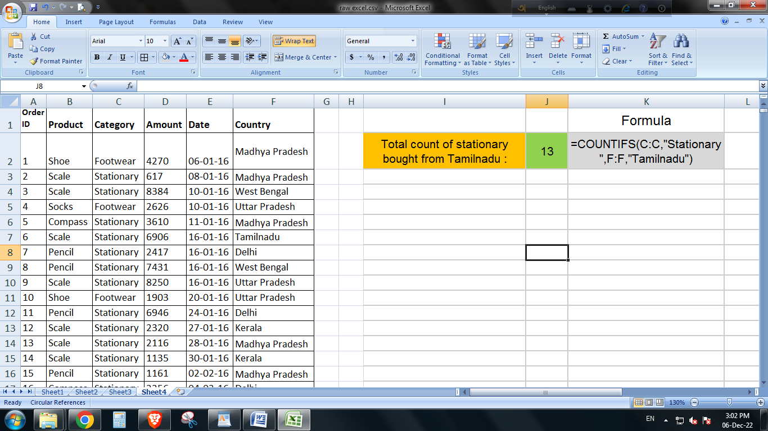

**3. What is the total amount spent on footwear?**

Ans: Rs. 194226/-

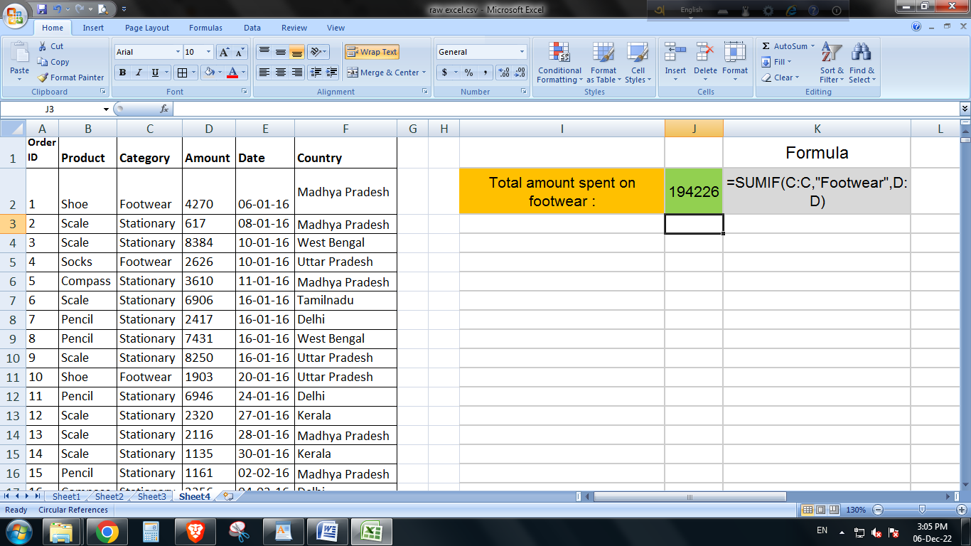

**4. What is the total amount of money spent for stationary in July?**

Ans: Rs. 53398/-

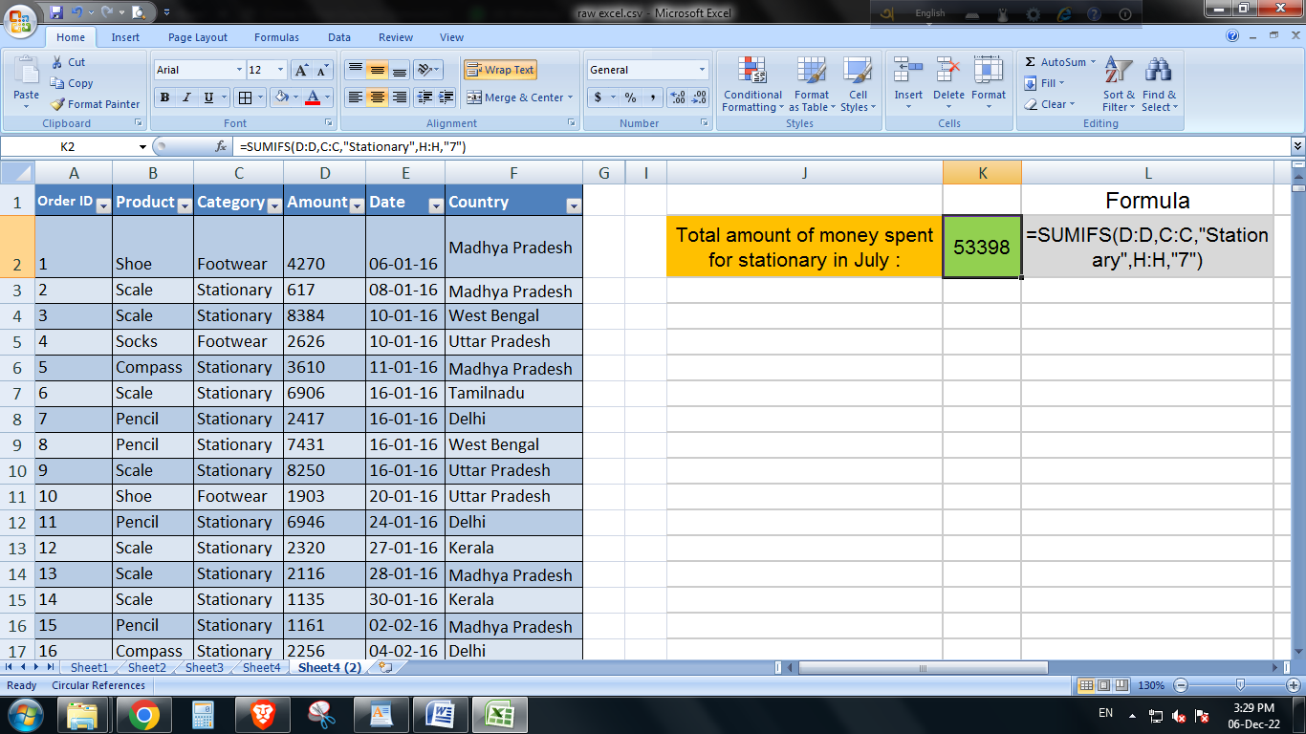

**5. What is the count of footwear that is coming from Delhi?**

Ans: 27.

